# JS Advanced - Retake Exam: 19.12.2018

# Problem 1. X-mas Gifts

Use the **index.html** and **app.js** files to solve this problem.

**Note**: You **can't** and you have **no permission** to change directly the given html code (index.html file)

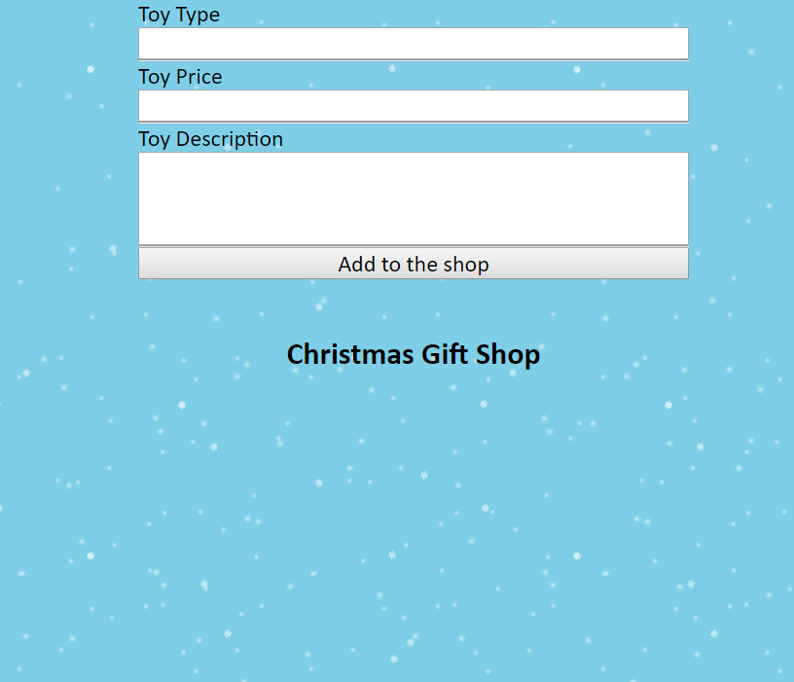

## Your task

**Write the missing JavaScript code** to make this **Christmas gift shop** work properly as follows:

When **all** fields (**Toy Type**, **Toy Price** and **Toy Description**) **are filled with** **correct input**:

* **Toy Type ->** **non-empty string**.
* **Toy Price** **-> number**.
* **Toy Description** **-> non-empty** **string** **with** **no more than** **50 characters!**

and "**Add to the shop**" button **is** **pressed, a new gift (offer)** should appear into the shop showcase.

**If one or all condition is not met, you should do nothing!**

## Example

Toy Type - **Red Car**  
Toy Price - **12.99**  
Toy Description - **Car plays a melody, fun phrases, and snorting sounds Peppa and Mummy Pig articulated figures Requires 2 AA batteries Suitable for age 2 years and up.**

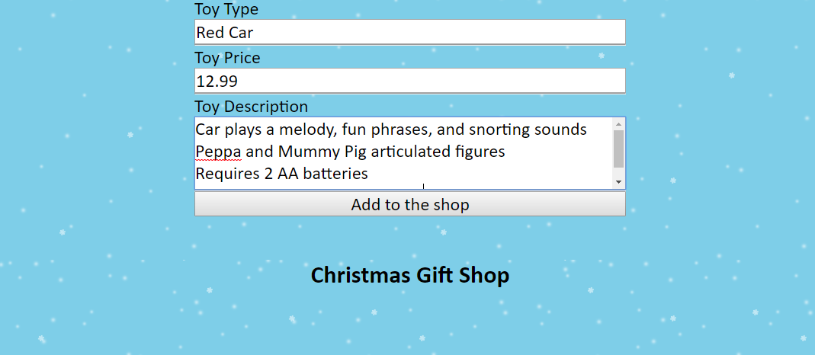

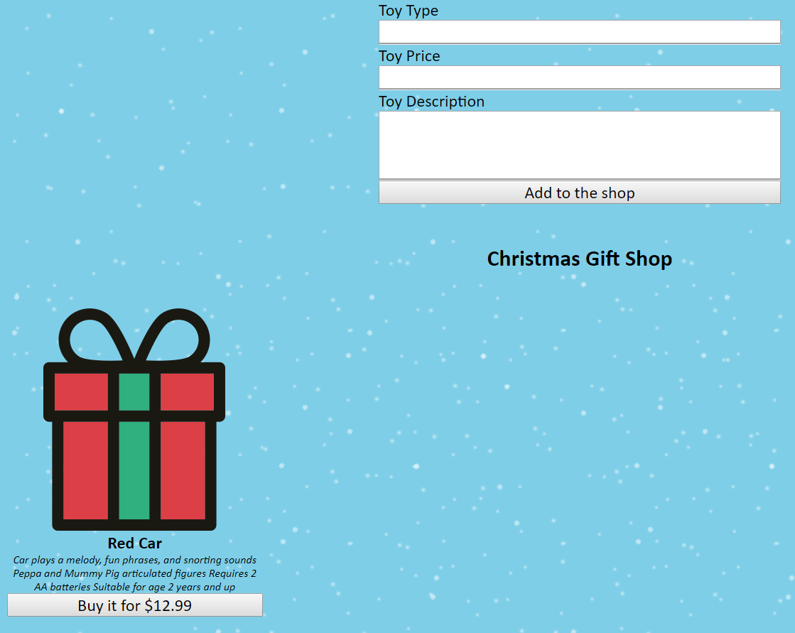

## Closer look on the gift element

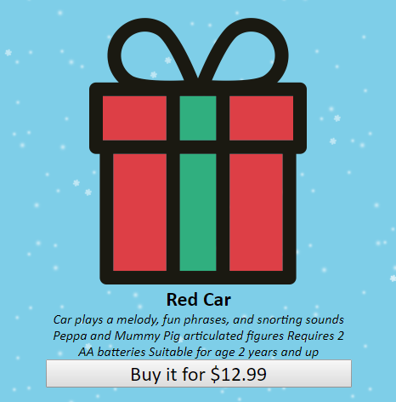

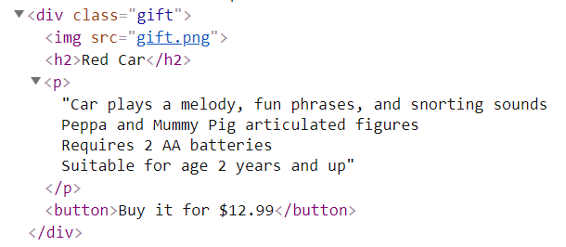

**All gifts in the shop showcase have the same image source!**

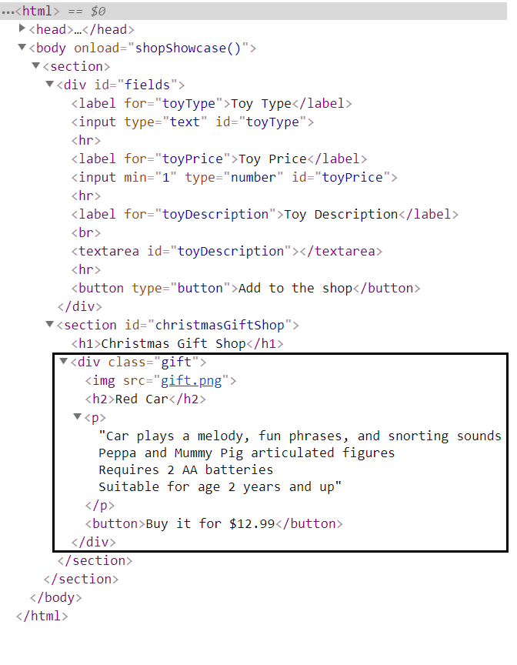

**Аnd last but not least**, if the **button** on a **gift** (offer) is pressed, the current gift **must disappear** from the shop showcase.

In this case, if we click over the "**Buy it for $12.99**" button, **the expected result** should be as if we had not put a **Red Car** **gift** (offer) in the shop showcase at all:

